# EXP NO:2a SHELL SCRIPT

PROGRAM

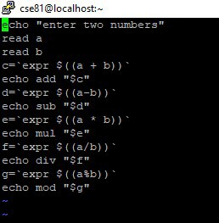

OUTPUT

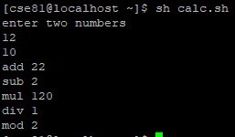

# EXP NO:2b

PROGRAM

Adithya .J

230701013

CSE A

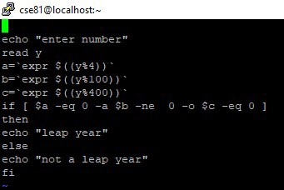

OUTPUT

